**LIT ASSIGNMENT DAY 15**

NAME: Rachepalli Madhavi

EMPLOYEE ID: 46255250

Batch Name: SAP ABAP – 25

Assignment 1 – Create a Simple program to fetch data and display ALV using Std. SAP class-methods.

Program to fetch data:

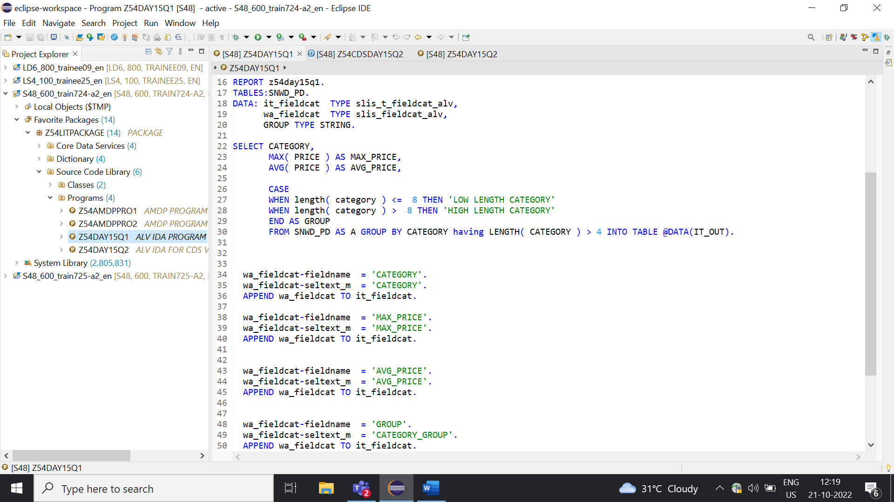

Output:

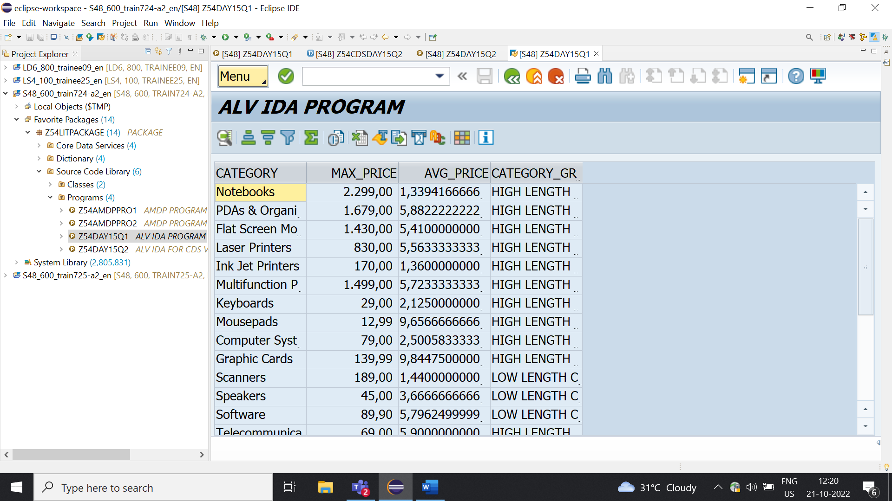

Assignment 2 – ALV with IDA.

Scenario –

* Create one CDS view by selecting fields VBELN, POSNR, VKORG, MATNR, MENGE from VBAK and VBAP table.
* Fetch records from CDS view in ABAP program.

CDS View:

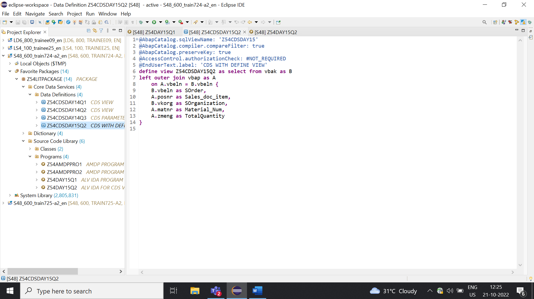

Output:

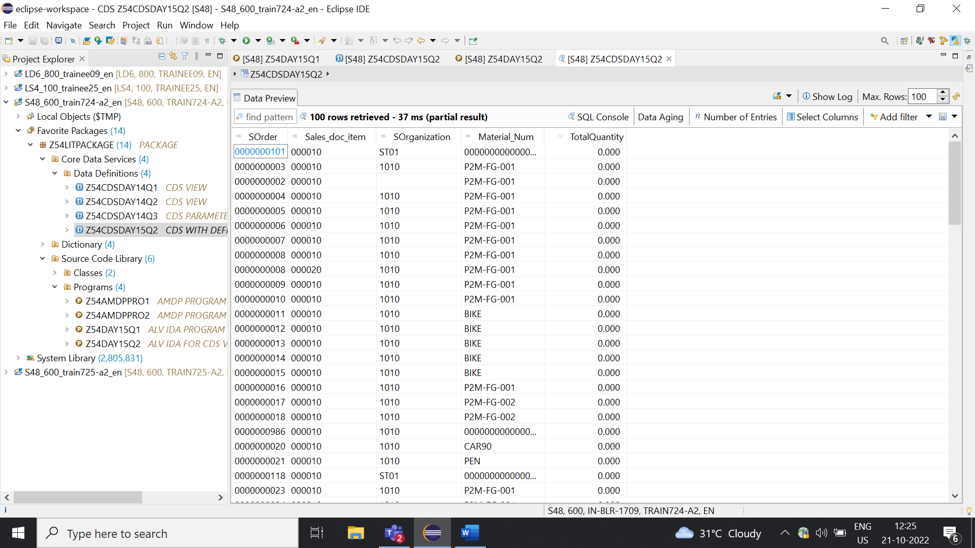

Fetched records from CDS View to ABAP Program:

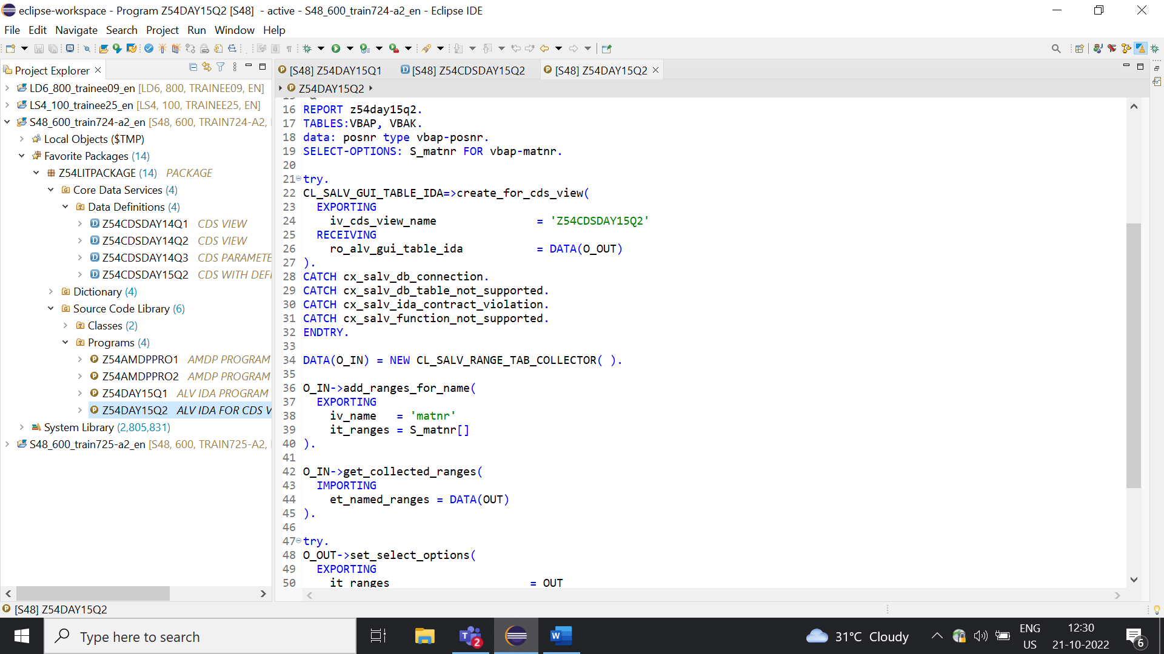

Output:

